**Class:** Final Year (Computer Science and Engineering)

**Year:** 2024-25 **Semester:** 1

**Course:** High Performance Computing Lab

**Practical No. 6**

**Exam Seat No:21510043**

**name:shweta avinash kakade**

**Title of practical: Implementation of OpenMP programs.**

Implement following Programs using OpenMP with C:

1. Implementation of Matrix-Matrix Multiplication.
2. Implementation of Matrix-vector Multiplication.

**Problem Statement 1:**

**Screenshots:**

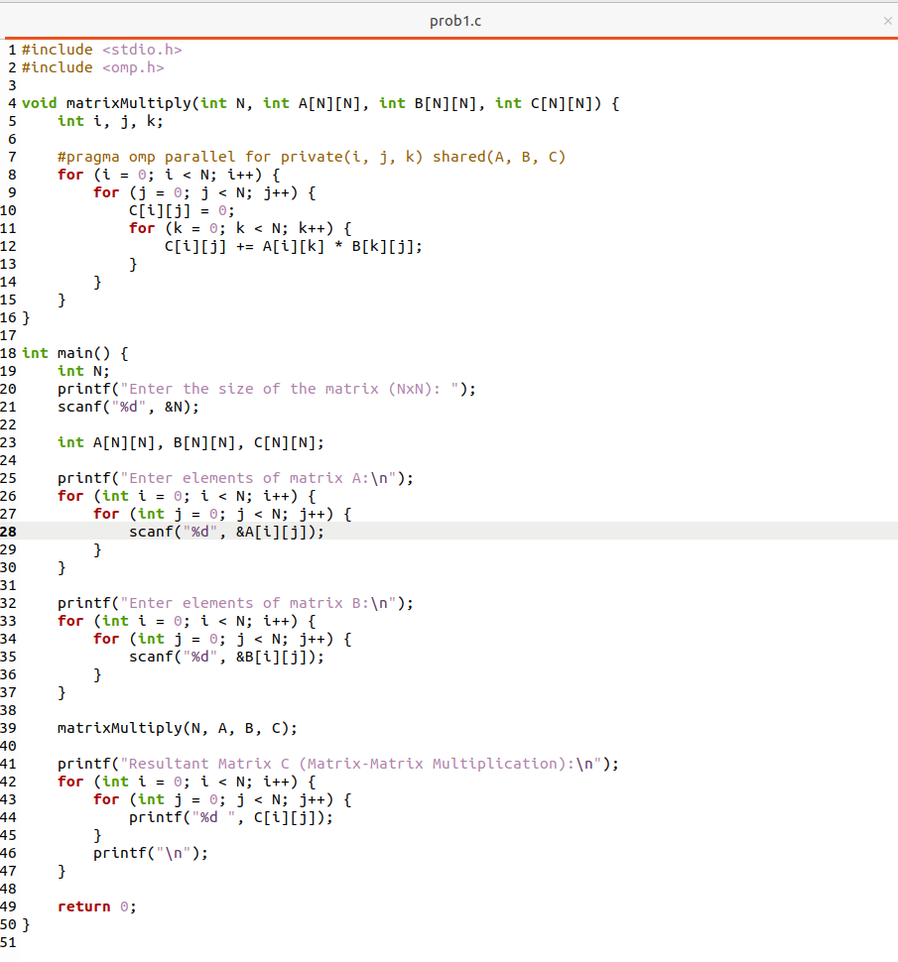

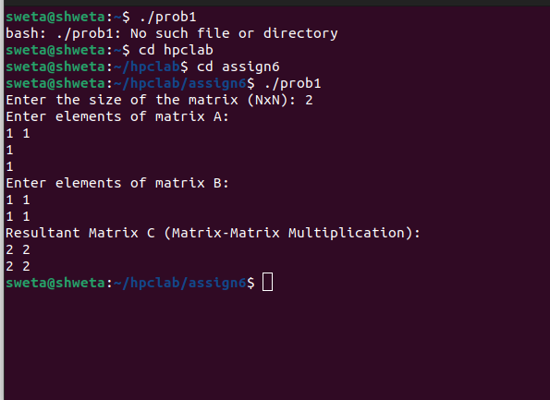

**Information:**

**This program performs matrix-matrix multiplication of two square matrices using OpenMP for parallelism. The multiplication process involves iterating through rows and columns of matrices A and B to compute each element of the resultant matrix C.**

**Analysis:**

**By parallelizing the outer loop with OpenMP, multiple threads compute different rows of the result matrix simultaneously, which can significantly reduce computation time on multi-core processors. Using private variables for loop indices avoids race conditions, ensuring each thread operates independently without data corruption.**

**Problem Statement 2:**

**Screenshots:**

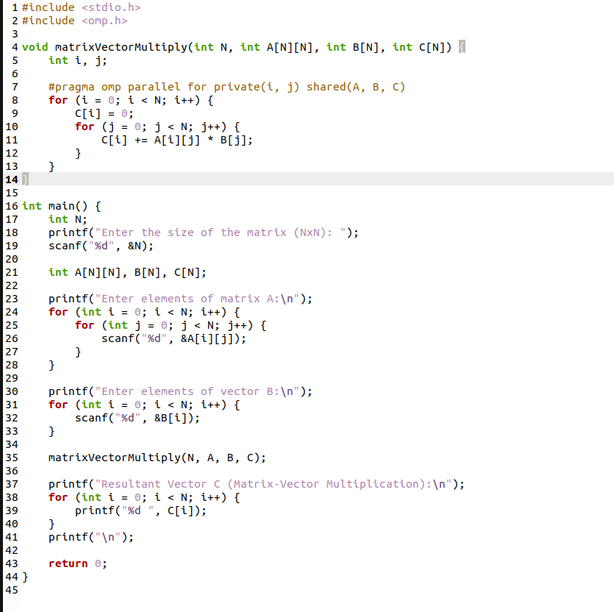

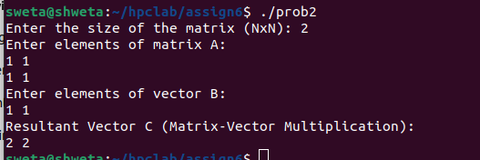

**Information:**

**his program performs matrix-vector multiplication using OpenMP to parallelize the outer loop. The program computes the product of matrix A and vector B, storing the result in vector C, where each element is the dot product of a row of A and the vector B.**

**Analysis:**

**Parallelizing the matrix-vector multiplication improves performance by dividing the computation of different elements of the resultant vector across threads. The program ensures safe multi-threaded execution by making loop indices private to each thread, preventing conflicts while enhancing speed for larger matrices.**

**Github Link:**

**https://github.com/shweta29k/HPC_LAB**